Zulu Kings -Special Day Tour
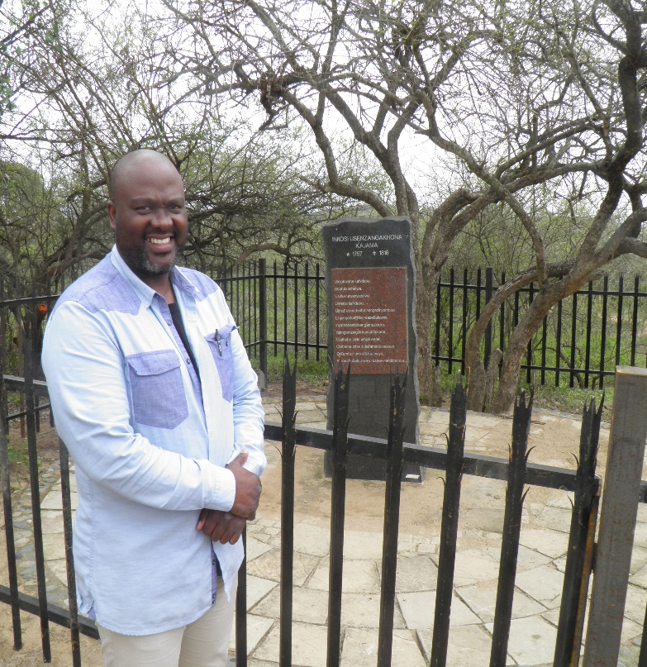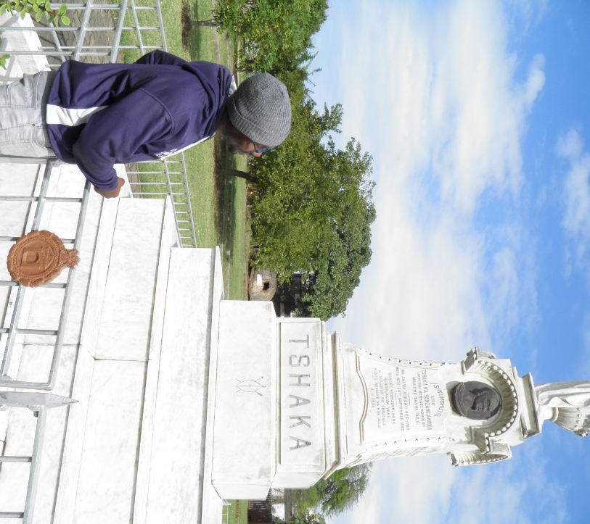
Graves of Senzanhkona and Shaka
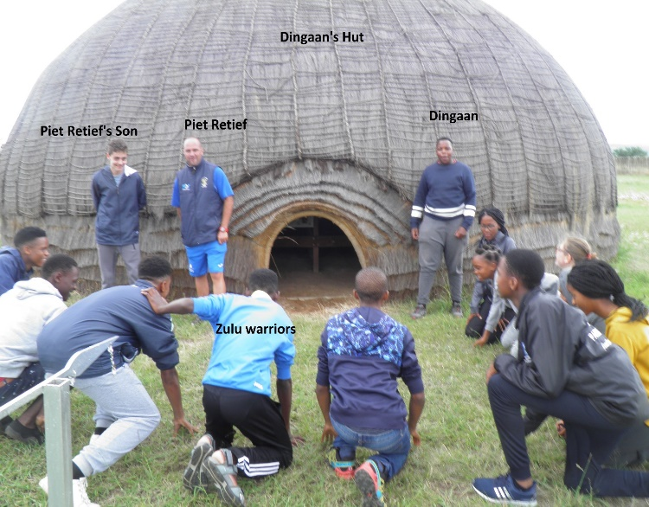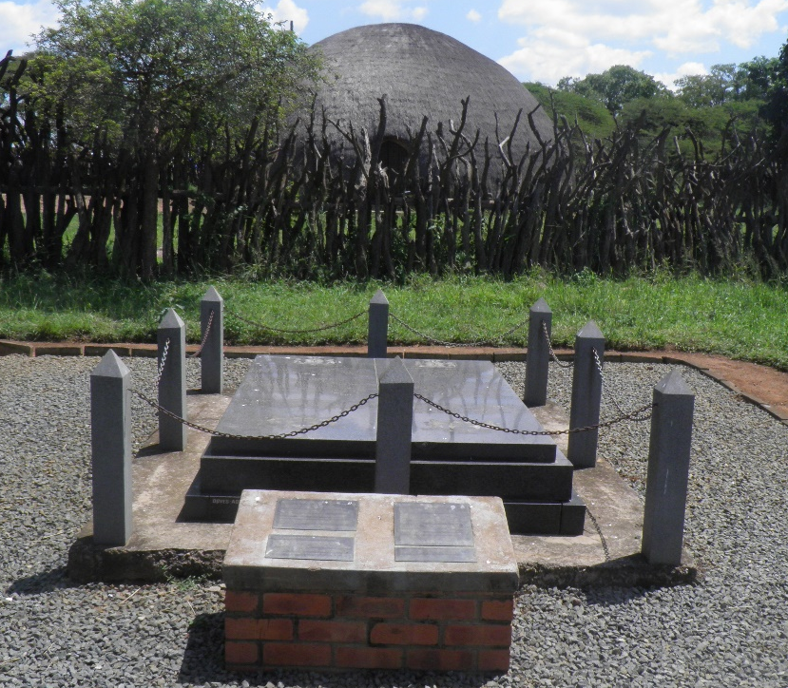
Dingaan’s Umgungundlovu Mpande
07h30 Depart from ICC with stops at kwaDakuza, Fort Pearson, Umgungundlovu and Ulundi (Mpande). Life history of the Zulu Kings, photos taken at each stop, light lunch (Steak roll a fruit and juice) at Umgungundlovu. Return to ICC by 17h30.
Cost is depending on numbers. Contact Kevin Smith at 0845559600 or by E Mail kevin@sansafaris.co.za

